Title : Prepare setup for Mininet network emulation environment with the help of Virtualbox and Mininet. Demonstrate the basic commands in Mininet and emulate different custom network topology (Simple, Linear, and Tree).View flow tables.
Name : - Mehatab Mahibub Sanadi
Roll No. : - CO4050
Class : - BE Computer
Subject : - Software Defined Networks
*********************************************************************
Step 1: Install Required Tools (Ubuntu)
sudo apt update
sudo apt install mininet openvswitch-switch git python3 -y

Step 2: Install POX Controller
cd ~
git clone https://github.com/noxrepo/pox.git
cd pox
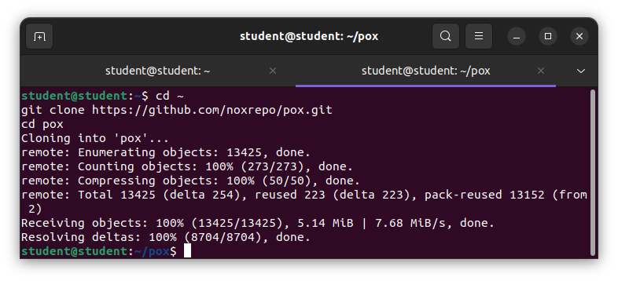
Step 3: Start POX Controller
sudo python3 pox.py forwarding.l2_pairs openflow.discovery info.packet_dump samples.pretty_log log.level --DEBUG
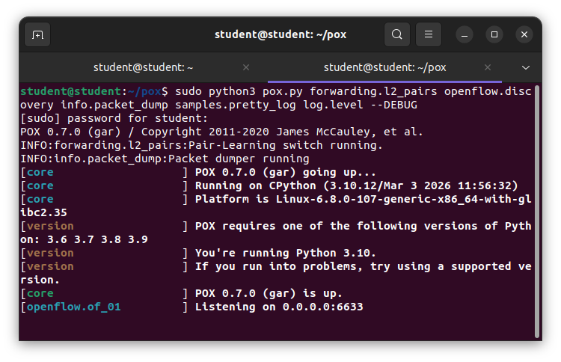
What this does:
Acts as Layer-2 learning switch
Logs packets and flow installation

Step 4: Create Custom Topology (Remote Controller)
Structure:
3 switches → s1, s2, s3
4 hosts → h1, h2, h3, h4
Controller connected to all switches
Run Mininet with Remote Controller
Open new terminal:
sudo mn --topo tree,depth=2,fanout=2 --controller=remote,ip=127.0.0.1,port=6633
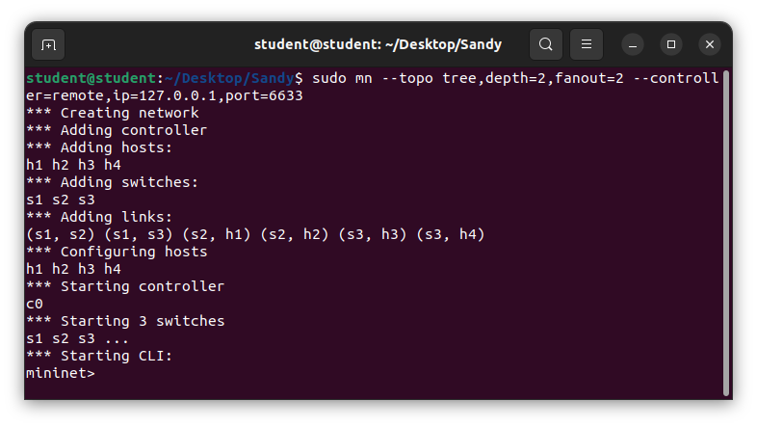
This matches your topology:
s3 → core switch
s1, s2 → edge switches
Each switch → 2 hosts
Step 5: Verify Topology
Inside Mininet:
nodes
net
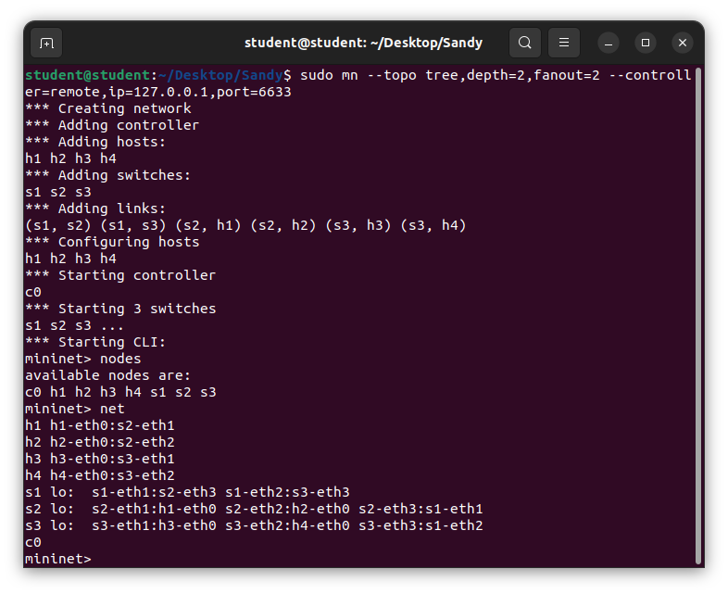
Step 6: Test Controller
Pingall
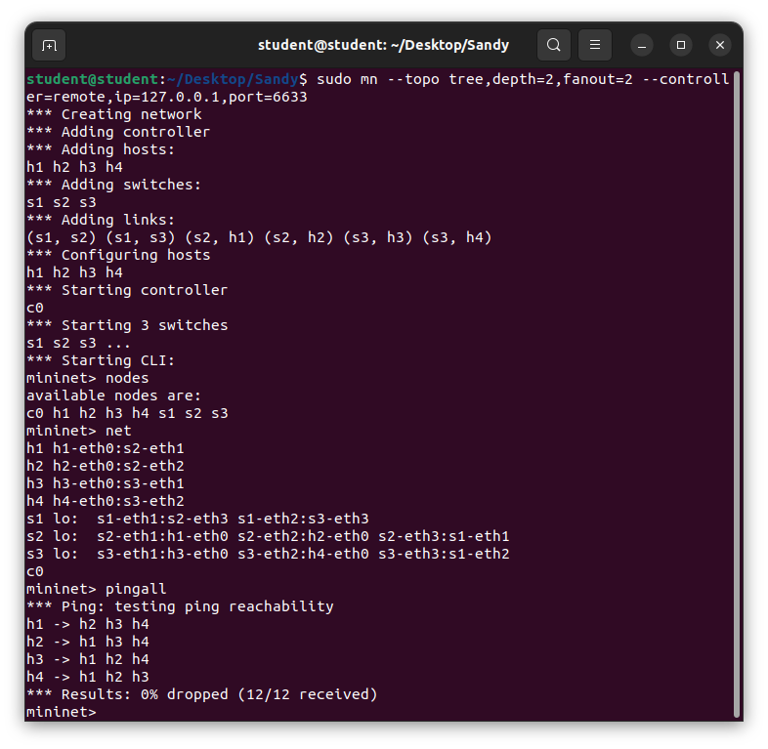
What happens:
- First packets go to controller
- Controller installs flows
- Then communication becomes fast

Step 7: Observe POX Logs
Look at POX terminal:
You will see:
- Packet-in messages
- Flow installation logs
- MAC learning
This confirms controller is working
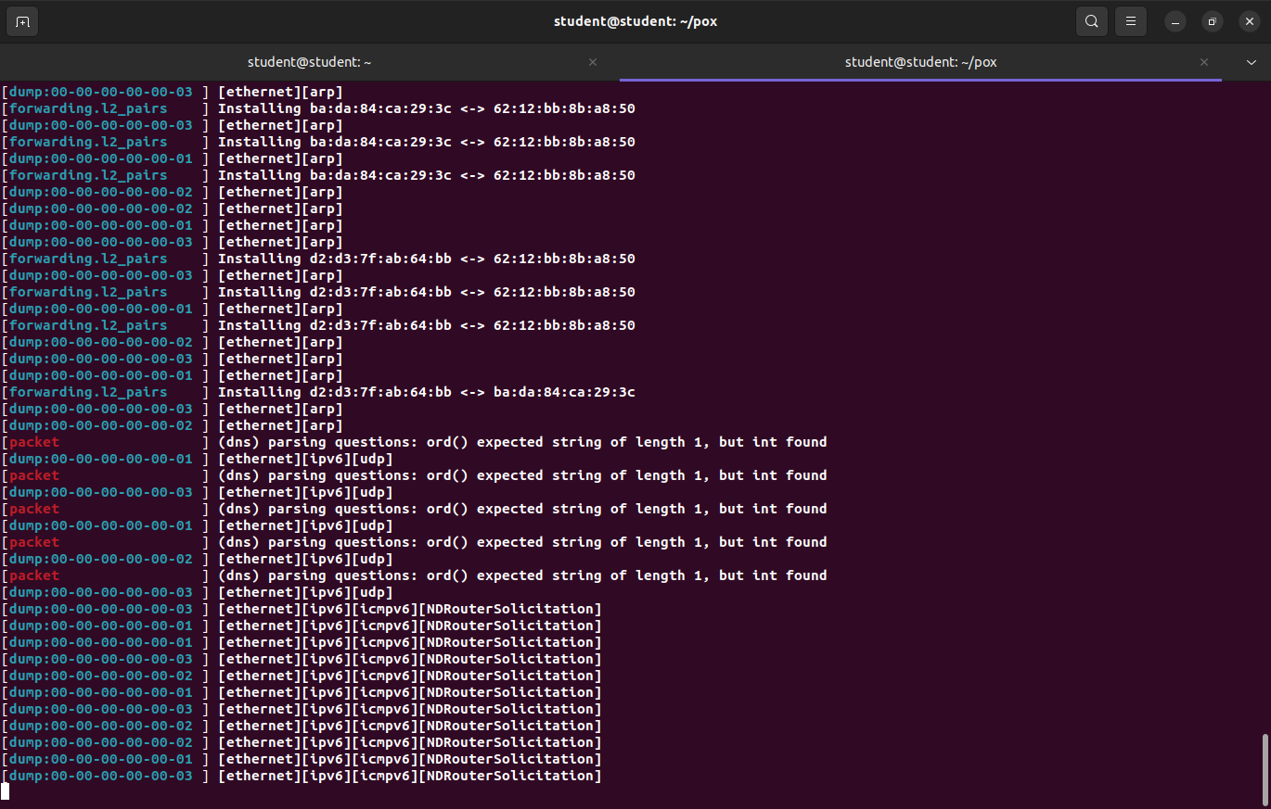

Step 8: View Flow Tables
Inside Mininet CLI:
dpctl dump-flows
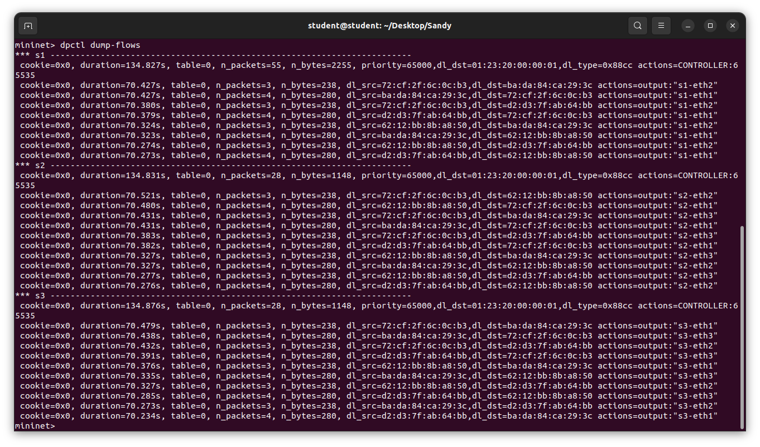
Shows:
- Flow entries added by controller
- MAC-based forwarding rules

Step 9: Clear Flow Tables
dpctl del-flows
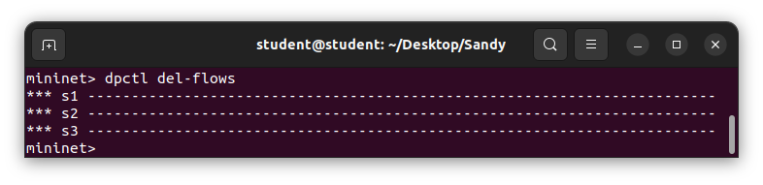
Step 10: Check ARP Tables
h1 arp
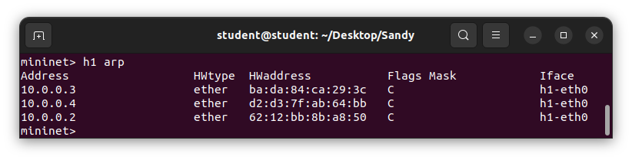
Step 11: Exit & Clean
exit
sudo mn -c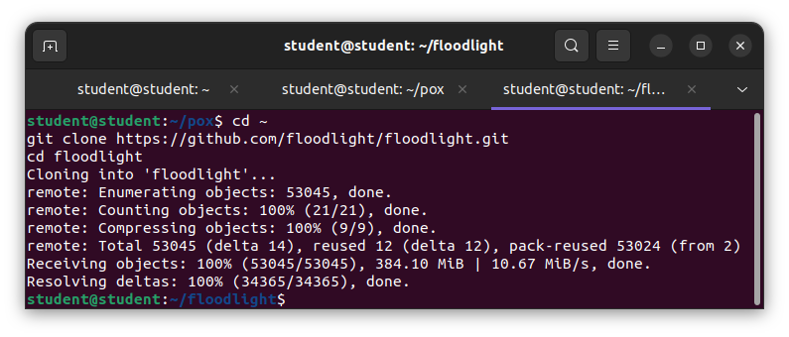
Conclusion:We learn how to install controller and run custom topology using remote controller like POX and floodlight controller. Recognize inserted flows by controller

